Table 1 – Equipment Names and Best Practice Tips

Includes equipment terms commonly used by different trades and geographic areas
- ‘Best practice’ tips are intended to help employers and their employees operate the equipment-control options effectively and are based on 1) OSHA’s Small Entity Compliance Guide for the Respirable Crystalline Silica Standard for Construction; 2) manufacturer specifications; and/or 3) craft worker/contractor input based on experience in the field.
Equipment/ Control | Photo | Names | Best Practice Tips
(i) Stationary masonry saws  CONTROL:  water | 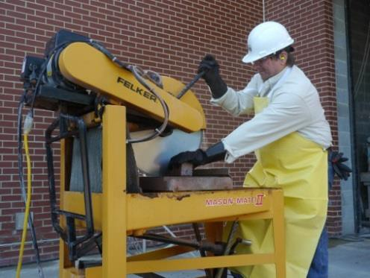  Photo courtesy of the International Masonry Institute & OSHA | Table saw Brick/block saw | OSHA1 requires the employer to ensure that:  - The saw is equipped with an integrated water delivery system (commercially developed specifically for the type of tool in use)  - An adequate supply of water for dust suppression  - The spray nozzle is working properly to apply water at the point of dust generation  - The spray nozzle is not clogged or damaged  - All hoses and connections are intact  - Water is applied at least at the flow rate specified by the manufacturer  - Additional exhaust is provided as needed to minimize the accumulation of visible airborne dust when operating indoors or in an enclosed space (area where airborne dust can build up)  Other tips:  - Visually inspect the water attachment to ensure it is properly connected to the water source and the tool  - Inspect the blade for cracks, loose segments, or other damage  - Check the hose or water tubes and the water flow rate regularly to ensure it is sufficient to control the dust generated so that no visible dust2 is emitted from the process once the blade has entered the substrate (material) being cut  - If recycling water, check regularly to make sure the water is circulating and change water to avoid silt build-up in water  - Prevent wet slurry from accumulating and drying

Equipment/ Control | Photo | Names | Best Practice Tips
(ii) Handheld power saws (any blade diameter)  CONTROL:  water + respirators3 (APF 10 outdoors more than 4 hours or all times indoors) | 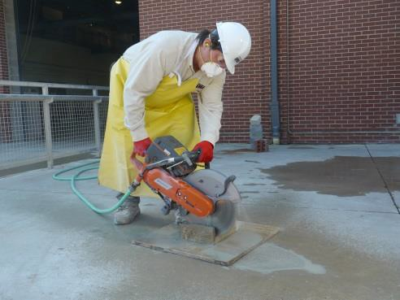  Photo courtesy of the International Masonry Institute & OSHA | Chop saw Cut-off saw Wet saw Partner saw | OSHA1 requires the employer to ensure that:  - An adequate supply of water for dust suppression is used  - The spray nozzle is working properly to apply water at the point of dust generation  - The spray nozzle is not clogged or damaged  - All hoses and connections are intact  - Water is applied at least at the flow rate specified by the manufacturer  - Additional exhaust is provided as needed to minimize the accumulation of visible airborne dust when operating indoors or in an enclosed space (area where airborne dust can build up)  Other tips:  - Visually inspect water attachment to ensure it is properly connected to the water source and the tool  - Inspect the blade for cracks, loose segments, or other damage  - Check the hose and the water flow rate regularly to ensure it is sufficient to control the dust generated so that no visible dust2 is emitted from the process once the blade has entered the substrate (material) being cut  - Prevent wet slurry from accumulating and drying  - Adjust nozzles so that water goes to the cutting area but still cools the blade

Equipment/ Control | Photo | Names | Best Practice Tips
(iii) Handheld power saws for cutting fiber- cement board (with blade diameter of 8 inches or less)  CONTROL:  ventilation (local exhaust ventilation or LEV) | 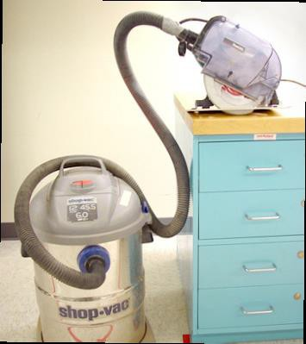  Photo courtesy of NIOSH | Worm drive Circular saw Cement saw | OSHA1 requires the employer to ensure that:  - The shroud or cowling is intact and installed in accordance with the manufacturer’s instructions  - The hose connecting the tool to the vacuum is intact and without kinks or tight bends  - The filter(s) on the vacuum are cleaned or changed in accordance with the manufacturer’s instructions to prevent clogging  - The dust collection bags are emptied to avoid overfilling  - The air flow rate is equal to or greater than recommended by the manufacturer  Other tips:  - When working indoors, provide sufficient ventilation to prevent build-up of visible airborne dust  - Visually inspect the blade, hood (shroud or cowl), and the shop vacuum system for missing or damaged parts  - Check the hood (shroud or cowl) and dust collection system regularly to ensure the system is operating so that no visible dust2 is emitted from the process once the blade has entered the substrate (material)  - The hose should be of sufficient size (≤1.25-inch inner diameter) to allow adequate airflow for the dust capture and transport, only be as long as necessary, and be kept as straight as possible  - Visually inspect the blade, hood (shroud or cowl) and shop vacuum system to ensure they are properly connected  - A high efficiency disposable filter bag can be used as a prefilter in the shop vacuum to capture most of the dust to prolong the life of the filter cartridge  - Plug the shop vacuum or saw into intelligent vacuum switches or use a shop vacuums with a built-in intelligent vacuum switch  - Regularly clean the saw, check and replace the filter, and empty the dust collection unit to prevent clogging and overheating  - Do not use compressed air to clean the equipment, filters, work clothing, or work environment -- compressed air can damage the filter

Equipment/ Control | Photo | Names | Best Practice Tips
(iv) Walk-behind saws  CONTROL:  water + respirators only when working indoors or in an enclosed area3 (APF 10) | 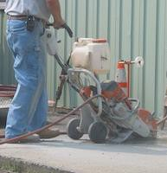  Photo courtesy of the NJ Department of Health and Senior Services' NIOSH-funded Silicosis Surveillance Project | Concrete saw Floor saw | OSHA1 requires the employer to ensure that:  - An adequate supply of water for dust suppression is used  - The spray nozzle is working properly to apply water at the point of dust generation  - The spray nozzle is not clogged or damaged  - All hoses and connections are intact  - Water is applied at the flow rate specified by the manufacturer or greater  - Additional exhaust is provided as needed to minimize the accumulation of visible airborne dust when operating indoors or in an enclosed space (area where airborne dust can build up)  Other tips:  - Visually inspect the water attachment to ensure it is properly connected to the water source and the tool  - Inspect the blade and shroud for cracks, loose segments, or other damage  - Check the water nozzles and the water flow rate regularly to ensure it is sufficient to control the dust generated so that no visible dust2 is emitted from the process once the blade has entered the substrate (material) being cut  - Prevent wet slurry from accumulating and drying

Equipment/ Control | Photo | Names | Best Practice Tips
(v) Drivable saws  CONTROL:  water | 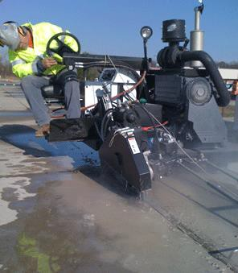  Photo courtesy of Diamond Products Limited |  | OSHA1 requires the employer to ensure that:  - An adequate supply of water for dust suppression is used  - The spray nozzles produce a pattern that applies water at the point of dust generation  - The spray nozzles are not clogged or damaged  - All hoses and connections are intact  - Water is applied at the flow rate specified by the manufacturer or greater  - Additional exhaust is provided as needed to minimize the accumulation of visible airborne dust when operating indoors or in an enclosed space (area where airborne dust can build up)  Other tips:  - Visually inspect the water attachment to ensure it is properly connected to the water source and the tool  - Inspect the blade and shroud for cracks, loose segments, or other damage  - Check the water nozzles and the water flow rate regularly to ensure it is sufficient to control the dust generated so that no visible dust2 is emitted from the process once the blade has entered the substrate (material) being cut  - Prevent wet slurry from accumulating and drying

Equipment/ Control | Photo | Names | Best Practice Tips
(vi) Rig-mounted core saws or drills  CONTROL:  water | 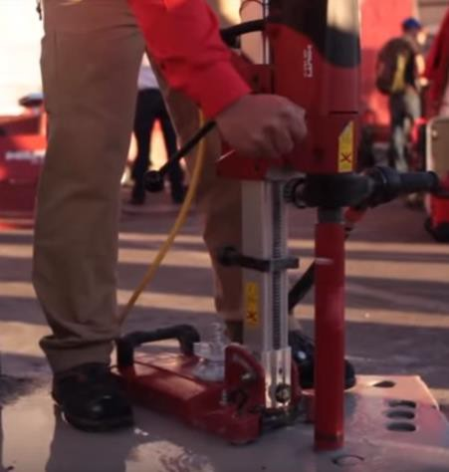  Photo courtesy of Hilti, Inc. Copyright 2017 | Core drilling machine/ equipment | OSHA1 requires the employer to ensure that:  - The saw or drill is equipped with an integrated water delivery system (commercially developed specifically for the type of tool in use)  - The equipment is operated in accordance with manufacturer’s instructions to minimize dust emissions.  - An adequate supply of water for dust suppression is used  - The spray nozzles produce a pattern that applies water at the point of dust generation  - The spray nozzle is not clogged or damaged  - All hoses and connections are intact  - Additional exhaust is provided as needed to minimize the accumulation of visible airborne dust when operating indoors or in an enclosed space (area where airborne dust can build up)  Other tips:  - Visually inspect the water attachment to ensure it is properly connected to the water source and the tool  - Inspect the drill for cracks, loose segments, or other damage  - Water is at the flow rate specified by the manufacturer or greater  - Check the hose or water tubes and the water flow rate regularly to ensure it is sufficient to control the dust generated so that no visible dust2 is emitted from the process once the blade has entered the substrate (material) being cut  - If recycling water, check regularly to make sure the water is circulating and change water to avoid silt build-up  - Prevent wet slurry from accumulating and drying

Equipment/ Control | Photo | Names | Best Practice Tips
(vii) Handheld and stand-mounted drills (including impact and rotary hammer drills)  CONTROL:  ventilation (local exhaust ventilation or LEV) | (Handheld)  Photo courtesy of the International Masonry Institute & OSHA  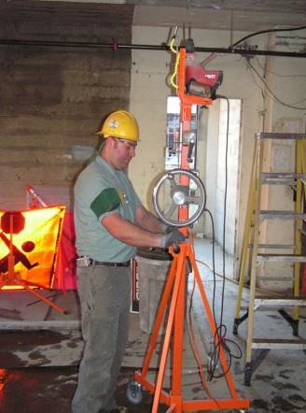  (Stand-mounted)  Photo courtesy of David Rempel | Hammer drill Rotohammer Roto-hammer | OSHA1 requires the employer to ensure that:  - The equipment is equipped with a commercially available shroud or cowling with a dust collection system that provides at least the minimum air flow required by the manufacturer  - The shroud or cowling is intact and installed in accordance with the manufacturer’s instructions  - The hose connecting the tool to the vacuum is intact and without kinks or tight bends  - The filter(s) on the vacuum are cleaned or changed in accordance with the manufacturer’s instructions  - The dust collection bags are emptied to avoid overfilling  - A HEPA-filtered vacuum is used when cleaning holes; compressed air can be used in conjunction with a HEPA-filtered vacuum or hole cleaning kit designed for use with compressed air  - Additional exhaust is provided as needed to minimize the accumulation of visible airborne dust when operating indoors or in an enclosed space (area where airborne dust can build up)  Other tips:  - Check the air flow rate to ensure it is equal to or greater than recommended by the manufacturer  - Visually inspect the drill, hood (shroud or cowl) and the dust collection system to ensure they are properly connected  - Visually inspect the drill, hood (shroud or cowl) and the dust collection system for missing or damaged parts  - Check the drill, hood (shroud or cowl), and dust collection system regularly to ensure the system is operating so that no visible dust2 is emitted from the process once the drill has entered the substrate (material)  - Check and replace the filter and empty the dust collection unit, and use filters and collection bags for collecting silica dust  - If applicable, regularly check the automatic filter cleaning system to ensure it is operating properly to maintain maximum air flow and suction power and can be used in conjunction with the HEPA filter
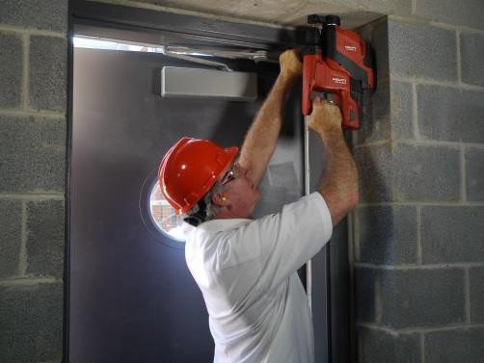

Equipment/ Control | Photo | Names | Best Practice Tips
(viii) Dowel drilling rigs for concrete  CONTROL:  ventilation  + respirators3 (APF 10) | 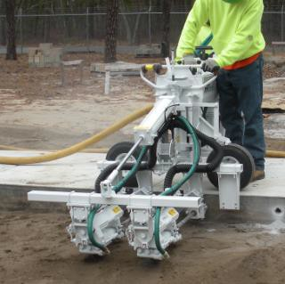  Photos courtesy of the Laborers Health and Safety Fund |  | OSHA1 requires the employer to ensure that:  - The shroud or cowling is intact and installed in accordance with the manufacturer’s instructions  - The hose connecting the tool to the vacuum is intact and without kinks or tight bends  - The filter(s) on the vacuum are cleaned or changed in accordance with the manufacturer’s instructions  - The dust collection bags are emptied to avoid overfilling  - The equipment is equipped with a shroud around the drill bit and a dust collection system that has a filter with 99% or greater efficiency  - The dust collection equipment has a filter cleaning mechanism  - A HEPA-filtered vacuum is used when cleaning holes; compressed air can be used in conjunction with a HEPA-filtered vacuum or hole cleaning kit designed for use with compressed air  Other tips:  - Visually inspect the tool, hood, and the dust collection system to ensure they are properly connected, and there are no missing or damaged parts  - Check the tool, hood, and dust collection system regularly to ensure the system is operating so that no visible dust2 is emitted from the process once the drill has entered the substrate (material)  - Use smooth ducts and maintain duct transport velocity at 3,500 to 4,000 feet per minute [ACGIH 2010]  - Provide duct clean-out points  - Install pressure gauges across dust collection filters so the drill operator knows when to clean or change the filter

Equipment/ Control | Photo | Names | Best Practice Tips
(ix) Vehicle- mounted drilling rigs for rock and concrete  CONTROL:  ventilation (local exhaust ventilation or LEV) + water  OR  enclosed cab + water |   Photo courtesy of NIOSH |  | OSHA1 requires the employer to implement dust collection systems and  water controls that ensure that:  - The shroud or cowling is intact and installed in accordance with the manufacturer’s instructions  - The hose connecting the tool to the vacuum is intact and without kinks or tight bends  - The filter(s) on the vacuum are cleaned or changed in accordance with the manufacturer’s instructions  - The dust collection bags are emptied to avoid overfilling  - An adequate supply of water for dust suppression is used  - The spray nozzles are working properly and produce a pattern that applies water on the discharge point from the dust collector  - The spray nozzles are not clogged or damaged  - All hoses and connections are intact OR  - Enclosed cab is:  - Maintained as free as practicable from dust  - Has door seals and closing mechanism that work properly  - Has gaskets and seals that are in good condition and work properly  - Is under positive pressure maintained through continuous delivery of filtered air  - Has intake air that is filtered through a pre-filter that is 95% efficient in the 0.3-100 µm range (e.g., MERV-16 or better)  - Has heating and cooling capabilities  - An adequate supply of water for dust suppression is used  - The spray nozzles are working properly and produce a pattern that applies water on the discharge point from the dust collector  - The spray nozzles are not clogged or damaged  - All hoses and connections are intact

Equipment/ Control | Photo | Names | Best Practice Tips
(x) Jackhammers and handheld powered chipping tools  CONTROL:  Water + respirators3 (APF 10 outdoors more than 4 hours; indoors all times)  OR  Ventilation+ respirators3  (Go to page 11 for details) | 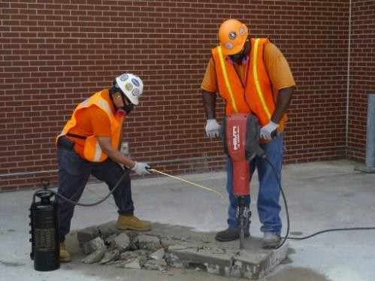  (water)  Photos courtesy of the International Masonry Institute & OSHA | Chipping hammer  Chipping gun Chisel gun | OSHA1 requires, for water controls, the employer to ensure that:  - A continuous stream or spray of water is delivered at the point of impact through direct connections to fixed water lines or portable water tank systems; one or two workers can operate the water delivery system  - An adequate supply of water for dust suppression is used  - The water sprays are working properly and produce a pattern that applies water at the point of dust generation  - The spray nozzles are not clogged or damaged  - All hoses and connections are intact  - Additional exhaust is provided as needed to minimize the accumulation of visible airborne dust when operating indoors or in an enclosed space (area where airborne dust can build up)  Other tips:  - Check the hose or spray nozzle regularly to ensure the flow rate is sufficient to control the dust generated so that no visible dust2 is emitted from the process once the breaker/drill has entered the substrate (material)  - Prevent wet slurry from accumulating and drying.

Equipment/ Control | Photo | Names | Best Practice Tips
(x) Jackhammers and handheld powered chipping tools  CONTROL:  Water + respirators3 (Go to page 10 for details)  OR  Ventilation+ respirators3 (APF 10)  (APF 10 outdoors more than 4 hours; indoors all times) | 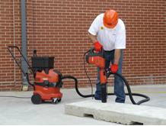  (vacuum)  Photos courtesy of the International Masonry Institute & OSHA | Chipping hammer  Chipping gun Chisel gun | OSHA1 requires, for dust collection controls, the employer to ensure  that:  - The system provides at least the air flow recommended by the manufacturer, a filter with 99% or greater efficiency, and a filter cleaning mechanism  - The shroud or cowling is intact and installed in accordance with the manufacturer’s instructions  - The hose connecting the tool to the vacuum is intact and without kinks or tight bends  - The filter(s) on the vacuum are cleaned or changed in accordance with the manufacturer’s instructions  - The dust collection bags are emptied to avoid overfilling  - Additional exhaust is provided as needed to minimize the accumulation of visible airborne dust when operating indoors or in an enclosed space (area where airborne dust can build up)  Other tips:  - Visually inspect the jackhammer/ impact driller, shroud (cowl or hood), and dust collection system to ensure they are properly connected  - Visually inspect the jackhammer/ impact driller, shroud (cowl or hood), and dust collection system for missing or damaged parts

Equipment/ Control | Photo | Names | Best Practice Tips
(xi) Handheld grinders for mortar removal (i.e. tuckpointing)  CONTROL:  ventilation (local exhaust ventilation or LEV) +  respirators3  (APF 10 4 hours or  less; APF 25 4 hours or more) |   Photo courtesy of the International Masonry Institute & OSHA | Tuckpointing grinder  Angle grinder Grinder | OSHA1 requires the employer to ensure that:  - The system provides at least 25 CFM of air flow per inch of wheel diameter, a filter with 99% efficiency or greater, and either a cyclonic pre-separator or a filter-cleaning mechanism  - The shroud or cowling is intact, encloses most of the grinding blade, and is installed in accordance with the manufacturer’s instructions  - The hose connecting the tool to the vacuum is intact and without kinks or tight bends  - The filter(s) on the vacuum are cleaned or changed in accordance with the manufacturer’s instructions  - The dust collection bags are emptied to avoid overfilling  - The blade is kept flush against the surface whenever possible  - The tool is operated against the direction of blade rotation whenever practical  - Additional exhaust is provided as needed to minimize the accumulation of visible airborne dust when operating indoors or in an enclosed space (area where airborne dust can build up)  Other tips:  - Visually inspect the grinder, shroud (cowl or hood), and dust collection system to ensure they are properly connected, there are no missing or damaged parts, and the system is operating so that no visible dust2 is emitted from the process once the grinder is flush against the work surface  - If applicable, regularly check the automatic filter cleaning system to ensure it is operating properly to maintain maximum air flow and suction power  - Place one side of the shroud against the working surface before inserting the blade into the mortar joint - this directs the dust into the shroud as the blade cuts into the mortar joint  - Do not move the grinder back and forth along the slot as this will create a gap that increase dust escape -- for better results, move the grinder in one direction, making a second pass only if necessary  - Back off the cutting pressure of the blade a short distance before removing it from the slot so the vacuum can have enough time to clear any dust buildup; use only enough cutting force to operate the tool effectively and keep the leading tool edge flush against the working surface

Equipment/ Control | Photo | Names | Best Practice Tips
(xii) Handheld grinders for uses other than mortar removal  CONTROL:  water  OR  ventilation (local exhaust ventilation or LEV) +  respirators3  (used indoors longer than 4 hours – APF10)  (Go to page 14 for details) | (water)  Photos courtesy of the International Masonry Institute & OSHA | Surface Grinder Sander  Polisher | OSHA1 requires, for water controls, the employer to ensure that:  - An integrated water system is provided that continuously feeds water to the grinding surface  - An adequate supply of water for dust suppression is used  - The spray nozzle is working properly and produce a pattern that applies water at the point of dust generation  - The spray nozzle is not clogged or damaged  - All hoses and connections are intact  - Additional exhaust is provided as needed to minimize the accumulation of visible airborne dust when operating indoors or in an enclosed space (area where airborne dust can build up)  Other tips:  - Visually inspect the water attachment to ensure it is properly connected to the water source and the tool, and for missing or damaged parts  - Check the hose and water flow rate regularly to ensure it is sufficient to control the dust generated so that no visible dust2 is emitted from the process once the grinder is flush with the cutting/work surface  - Prevent wet slurry from accumulating and drying  - Use the smallest wheel and least aggressive tool necessary to complete task  - Use a static pressure gauge, where available, to monitor performance
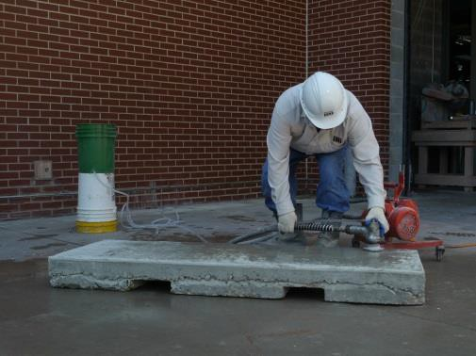

Equipment/ Control | Photo | Names | Best Practice Tips
xii) Handheld grinders for uses other than mortar removal  CONTROL:  water  (Go to page 13 for details)  OR  ventilation (local exhaust ventilation or LEV) +  respirators3  (used indoors longer than 4 hours  – APF10) | 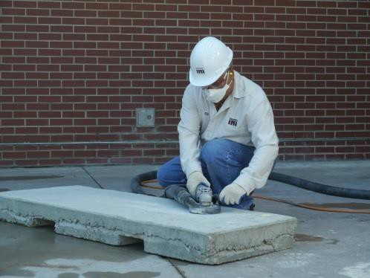  (vacuum)  Photos courtesy of the International Masonry Institute & OSHA | Surface Grinder Sander  Polisher | OSHA1 requires, for dust collection controls, the employer to ensure  that:  - The system provides at least 25 CFM of air flow per inch of wheel diameter, a filter with 99% efficiency or greater, and either a cyclonic pre-separator or a filter-cleaning mechanism  - The shroud or cowling is intact and is installed in accordance with the manufacturer’s instructions  - The hose connecting the tool to the vacuum is intact and without kinks or tight bends  - The filter(s) on the vacuum are cleaned or changed in accordance with the manufacturer’s instructions  - The dust collection bags are emptied to avoid overfilling  - Additional exhaust is provided as needed to minimize the accumulation of visible airborne dust when operating indoors or in an enclosed space (area where airborne dust can build up)  Other tips:  - Use the smallest wheel and least aggressive tool necessary to complete task  - Visually inspect the grinder, shroud (cowl or hood), and dust collection system to ensure they are properly connected, and for missing or damaged parts  - Check the grinder and dust collection system regularly to ensure the system is operating so that no visible dust2 is emitted from the process once the grinder is flush with the work surface/substrate.  - If applicable, regularly check the automatic filter cleaning system to ensure it is operating properly to maintain maximum air flow and suction power and can be used in conjunction with the HEPA filter  - Use a static pressure gauge, where available, to monitor performance

Equipment/ Control | Photo | Names | Best Practice Tips
(xiii) Walk-behind milling machines and floor grinders  CONTROL:  water  OR  ventilation  (Go to page 16 for details) | See photo with ventilation on page 16 |  | OSHA1 requires, for water controls, the employer to ensure that:  - An integrated water system is provided that continuously feeds water to the cutting surface  - An adequate supply of water for dust suppression is used  - The spray nozzles are working properly and produce a pattern that applies water at the point of dust generation  - The spray nozzles are not clogged or damaged  - All hoses and connections are intact  - Additional exhaust is provided as needed to minimize the accumulation of visible airborne dust when operating indoors or in an enclosed space (area where airborne dust can build up)  Other tips:  - Check the hose or spray nozzle regularly to ensure the flow rate is sufficient to control the dust generated so that no visible dust2 is emitted from the process once the breaker/drill has entered the substrate (material)  - Prevent wet slurry from accumulating and drying

Equipment/ Control | Photo | Names | Best Practice Tips
(xiii) Walk-behind milling machines and floor grinders  CONTROL:  water OR  ventilation | 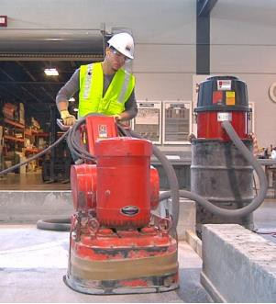  Photo courtesy of OSHA |  | OSHA1 requires, for dust collection controls, the employer to ensure  that:  - The system provides a filter with 99% efficiency or greater and a filter-cleaning mechanism  - The hose connecting the tool to the vacuum is intact and without kinks or tight bends  - The filter(s) on the vacuum are cleaned or changed in accordance with the manufacturer’s instructions  - The dust collection bags are emptied to avoid overfilling  - Additional exhaust is provided as needed to minimize the accumulation of visible airborne dust when operating indoors or in an enclosed space (area where airborne dust can build up)  - Loose dust must be cleaned with a HEPA-filtered vacuum in between passes of the machine to prevent the loose dust from being re-suspended  Other tips:  - Visually inspect the milling machine, shroud (hood or cowl) and dust collection system to ensure they are properly connected  - Visually inspect the milling machine, shroud (hood or cowl) and dust collection system for missing or damaged part  - Check the milling machine, shroud (hood or cowl) and dust collection system regularly to ensure the system is operating so that no visible dust2 is emitted from the process once the once the blade has entered the substrate being cut  - Use dust collector in accordance with manufacturer specifications including airflow rate

Equipment/ Control | Photo | Names | Best Practice Tips
(xiv) Small drivable milling machines (less than half-lane)  CONTROL:  water + surfactant | 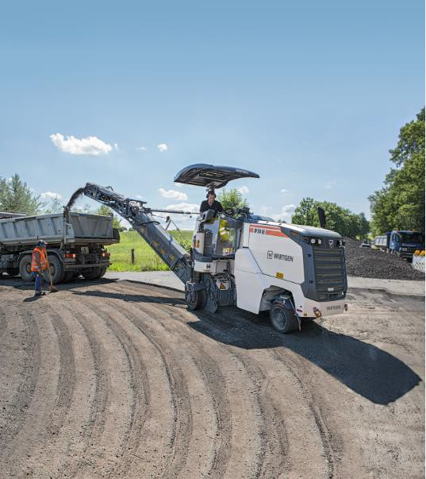  Photo courtesy of © WIRTGEN GmbH |  | OSHA1 requires the employer to ensure that:  - Supplemental water sprays are designed to suppress dust  - Water used is combined with a surfactant  - An adequate supply of water for dust suppression is used  - The spray nozzles are working properly and produce a pattern that applies water at the point of dust generation  - The spray nozzles are not clogged or damaged  - All hoses and connections are intact  - Additional exhaust is provided as needed to minimize the accumulation of visible airborne dust when operating indoors or in an enclosed space (area where airborne dust can build up)

Equipment/ Control | Photo | Names | Best Practice Tips
(xv) Large drivable milling machines (half-lane and larger)  CONTROL:  water + ventilation OR  water + surfactant (≤ 4 inch cuts) | 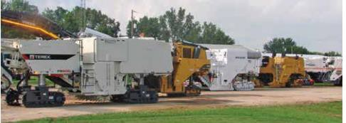  Photo courtesy of NAPA |  | OSHA1 requires, for cuts of any depth on asphalt only, the employer to  ensure that:  - The machine is equipped with exhaust ventilation drum enclosure and supplemental water sprays designed to suppress dust  - The machine is operated and maintained to minimize dust  For cuts of 4 inches or less:  - The machine is equipped with exhaust ventilation on the drum enclosure and supplemental water spray is designed to suppress dust  OR  - The machine is equipped with a supplemental water spray  - Water used is combined with a surfactant  Other tips:  - See NAPA field guide at http://www.silica-safe.org/training- and-other-resources/manuals-and-guides/asset/Field-Guide- for-Controlling-Silica-Dust-Exposure-on-Asphalt-Pavement- Milling-Machines.pdf  - Ensure the correct controls are being used for the depth of the asphalt cut

Equipment/ Control | Photo | Names | Best Practice Tips
(xvi) Crushing machines  CONTROL:  water + ventilated booth | 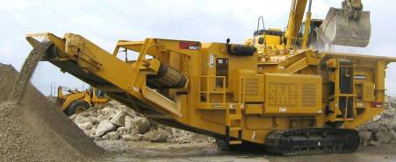  Used by permission of Screen Machine Industries™ |  | OSHA1 requires the employer to ensure that:  - A remote control station or ventilated booth that provides fresh, climate-controlled air operator, or a remote control station  - Enclosed cab or booth:  - Is maintained as free as practicable from settled dust  - Has door seals and closing mechanism that work properly  - Has gaskets and seals that are in good condition and work properly  - Is under positive pressure maintained through continuous delivery of filtered air  - Has intake air that is filtered through a pre-filter that is 95% efficient in the 0.3-100 µm range (e.g., MERV-16 or better)  - Has heating and cooling capabilities  - Water sprays or mists for dust suppression at the crusher and other points where dust is generated (e.g., hoppers, conveyers, sieves,/sizing or vibrating components, and discharge points)  - Nozzles are located upstream of dust generation points and positioned to thoroughly wet the material  - The volume and size of droplets is adequate to sufficiently wet the material (optimal droplet size is between 10 and 150 µm)  - Spray nozzles are located far enough from the target area to provide complete water coverage, but not so far that the water is carried away by wind

Equipment/ Control | Photo | Names | Best Practice Tips
(xvii) Heavy equipment and utility vehicles used to abrade or fracture silica- containing materials (e.g., hoe- ramming, rock ripping) or used during demolition activities involving silica-containing materials  CONTROL:  enclosed cab OR  Water + ventilation (if nearby workers outside cabs) | 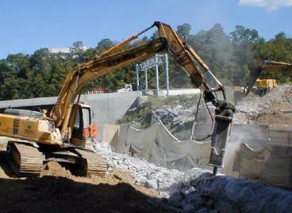  Photo Courtesy of OSHA Small Entity Compliance Guide for the Respirable Crystalline Silica Standard for Construction/CPWR |  | OSHA1 requires the employer to ensure that:  - Enclosed cab or booth:  - Is maintained as free as practicable from settled dust  - Has door seals and closing mechanism that work properly  - Has gaskets and seals that are in good condition and work properly  - Is under positive pressure maintained through continuous delivery of filtered air  - Has intake air that is filtered through a pre-filter that is 95% efficient in the 0.3-100 µm range (e.g., MERV-16 or better)  - Has heating and cooling capabilities  - When employees outside of the cab are engaged in the task, apply water and/or dust suppressants as necessary to minimize dust emissions

Equipment/ Control | Photo | Names | Best Practice Tips
(xviii) Heavy equipment and utility vehicles for tasks such as grading and excavating but not including: demolishing, abrading, or fracturing silica- containing materials  CONTROL:  enclosed cab OR  Water + ventilation (if nearby workers outside cabs) | Photo courtesy of NIOSH |  | OSHA1 requires the employer to ensure that:  - Apply water and/or dust suppressants as necessary to minimize dust emissions  - When the equipment operator is the only employee engaged in the task, operated equipment from within an enclosed cab or booth:  - Is maintained as free as practicable from settled dust  - Has door seals and closing mechanism that work properly  - Has gaskets and seals that are in good condition and work properly  - Is under positive pressure maintained through continuous delivery of filtered air  - Has intake air that is filtered through a pre-filter that is 95% efficient in the 0.3-100 µm range (e.g., MERV-16 or better)  - Has heating and cooling capabilities

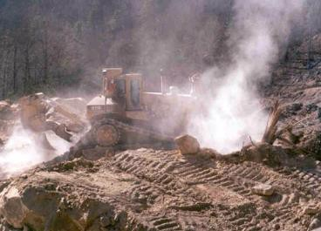

1Best practice requirements from OSHA’s Small Entity Compliance Guide for the Respirable Crystalline Silica Standard for Construction
2A small amount of visible dust may be present when the blade or tool initially enters the substrate and when it is being removed at the end of a task. However, if visible dust is present after the blade or tool has entered the work surface/substrate, this is a sign that the control is not working properly. The operation should be stopped and the
equipment and/or workers’ cutting technique checked and fixed.
3Respirator use is conditional on time spent using equipment and if task is done outdoors, indoors or in an enclosed area. See Table 1 in the standard for specific requirements including the assigned protection factor (respiratory protection).

